Fun Facts about Asia
Please fill in the blanks with the words here-

Taoism  Euphrates  Turkey  moon  Suez Canal  four | Dead Sea  Hong Kong  Caspian  Indian  Pacific  Arctic  Savage Mountain | Tigris  Japan  China  India  Mount Everest  Buddhism  Ural Mountains

1. Asia is the largest continent by landmass and human population. The area of Asia is larger than the land area of the _______. (44.6K sq km – 37k sq km respectively.)
2. Asia has a population of over ____ billion people or better than 60% of the world’s population. This many people standing side by side holding hands would reach around the world at the equator more than 100 times. More than half of Asia’s population is in two countries in Asia _____ (1.3 billion) and ______(1.1 billion).

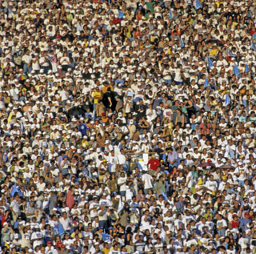

4. Asia’s boundaries extend from the ________ and __________ in the west, to the south of the Caucasus Mountains and ______ and Black Seas. Also to the South is the _______ Ocean, to the North the ______ Ocean and to the Far East the _____ Ocean.
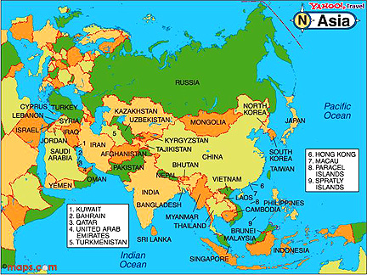
5. Asia can be divided into 6 subcontinents- Matching exercise and fill in the countries

___ 1. India Subcontinent | a. Kazakhstan Uzbekistan, __________, Tajikistan and Kyrgyzstan.
___ 2. North Asia | b. The Middle East including Turkey, Iran, ________, Cyprus, Israel, and ______.
___ 3. Central Asia | c. China, Japan, _______, ______, North and South Korea
___ 4. Southeast Asia | d. Russia
___ 5. Southwest Asia | e. _______, _______, Bangladesh, Bhutan, Maldives, Nepal, ______, Sri Lanka
___ 6. East Asia | f. Brunei, Cambodia, East Timor, Indonesia, Laos, _______, Myanmar [Burma], Philippines, Singapore, Thailand and _________

6. Three of the top four economies in the world are in Asia – China, _____. and India. They are numbers 2, 3 and 4 respectively. However, tiny _____ has less than 1/10th of the population of China or India. Yet Asia’s economy as a continent trails North America and Europe.
7. Asia’s three dominant financial centers are Tokyo, _______, and Singapore.
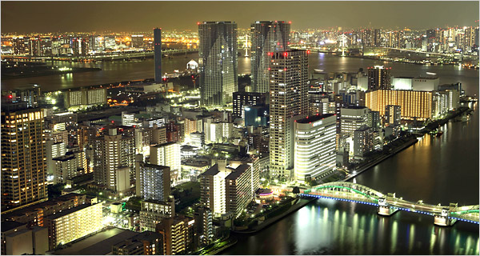
Tokyo Financial Center
8. Asia‘s dominant religions are Hinduism, ________, Confucian/______ and Islam.
9. Asia’s western most point is Cape Baba in Northwestern _____.
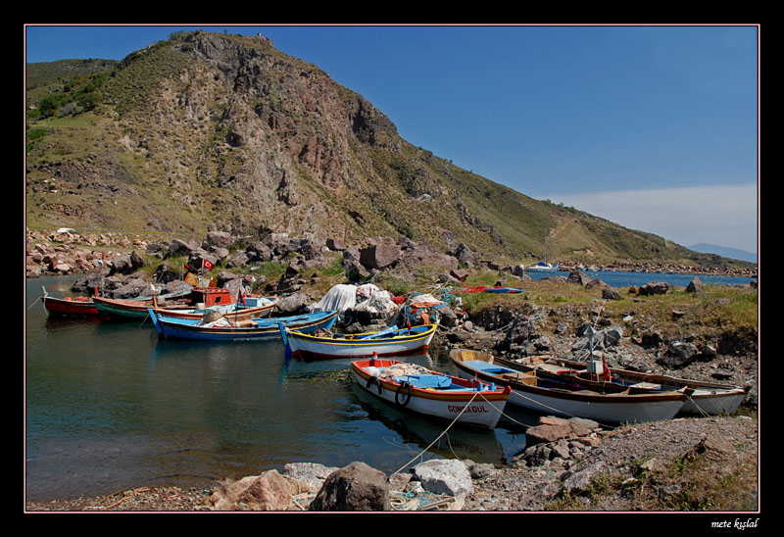
Cape Baba
10. Asia‘s eastern most point is Cape Chelyuskin in Siberia.
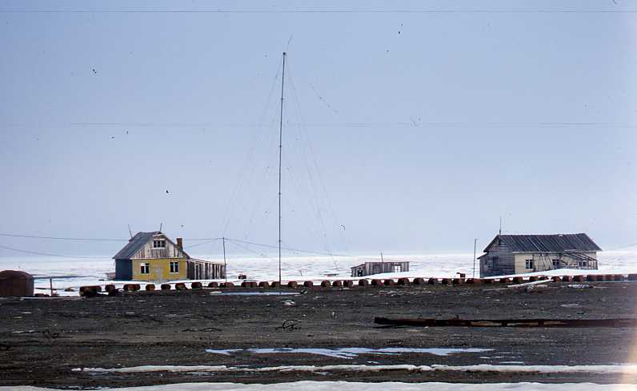
Cape Chelyuskin
11. Asia is 5,300 miles wide
12. Asia is home to the highest (___________ -8,848m) and lowest _______ (-395m) points on Earth.
13. Asia is home to the birth of the human species and civilization. Somewhere near where the ____ and ______ Rivers meet.
14. The ten longest rivers in Asia -
- Yangtze (Chang Jiang) – 6,300 km – 3,915 miles
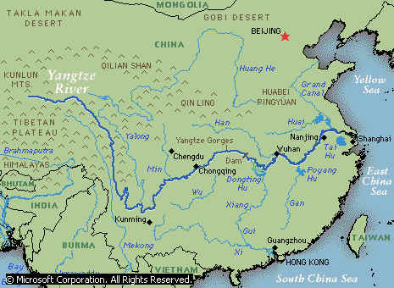
Yangtze (Chang Jiang)
- Yellow River (Huang He) – 5,464 km – 3,395 miles- located in ______________
- Lena River – 4,400 km – 2,734 miles
- Mekong River – 4,350 km – 2,703 miles
- Irtysh River – 4,248 km – 2,640 miles
- Yenisei River – 4,090 km – 2,540 miles
- Ob River – 3,650 km – 2,268 miles
- Nizhnyaya Tunguska River – 2,989 km – 1,857 miles
- Indus River – 2,900 km – 1,800 miles located in ______________
- Brahmaputra River – 2,900 km – 1,800 miles
if linked end to end would reach around the world at the equator.
15. The ten tallest mountains in Asia -
1. Everest (8,848 m), Nepal-Tibet
2. K2 (8,611 m), as knows as also known as ____________ located in Pakistan-China
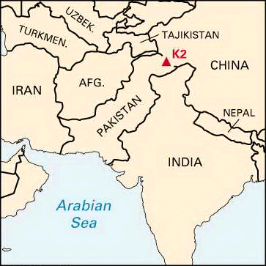
Where is K2
3. Kangchenjunga (8,586 m), Nepal-Sikkim, India
4. Lhotse (8,516 m), Nepal-Tibet, China
5. Makalu (8,462 m), Nepal-Tibet, China
6. Cho Oyu (8,201 m), Nepal-Tibet, China
7. Dhaulagiri (8,167 m), Nepal
8. Manaslu (8,156 m), Nepal
9. Nanga Parbat (8,125 m), Pakistan
10. Annapurna (8,091 m), Nepal
if stacked one on top of the other would reach into space.

